**PRACTICAL 06**

**1. Consider bridges.mt1.tab and bridges.mt2.tab files as input and do as directed:**

* **Concatenate the files**
* **Apply preprocessing for missing values**
* **Save the new file**
* **Open the new file and view it.**

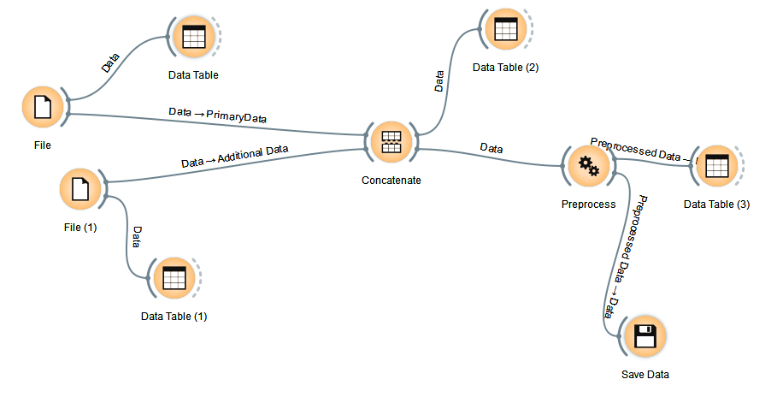

**2. Use the above file to**

* **Discretize the variables and find the type of river that is maximum in number, which type of material is majorly used?**
* **Consider only erected, type, river, purpose and length columns and save it as file- F1.tab**

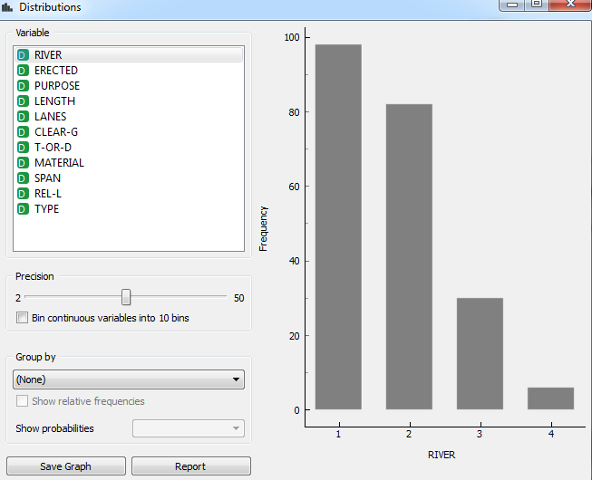

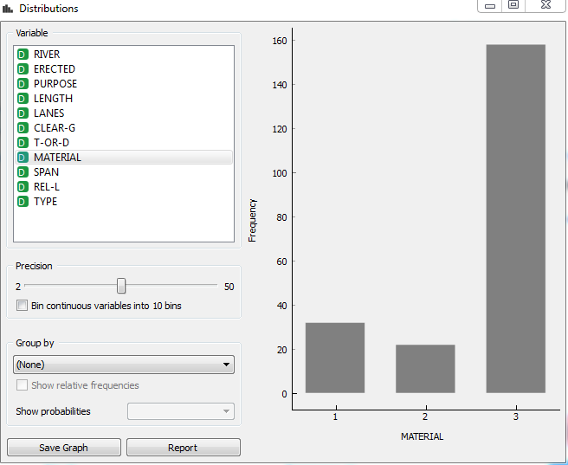

**3. Do as directed:**

* **Import auto-mpg.tab file. Make 2 parts of the file columns.**

**1. cylinders, weight, acceleration, model_year and car_name.**

**2. mpg, origin, horsepower, displacement and car_name.**

* **Consider these 2 parts and merge to get the original file.**

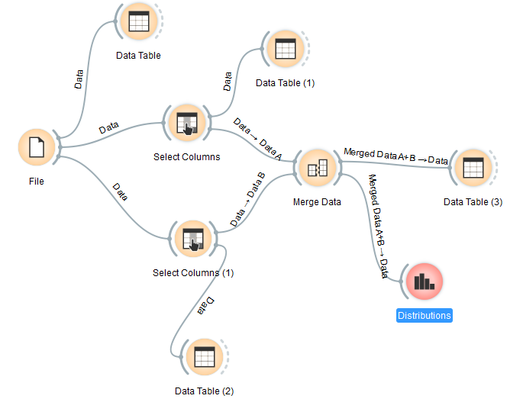

**Answer the following questions:**

1. **In which year maximum cars were built? - 1973**

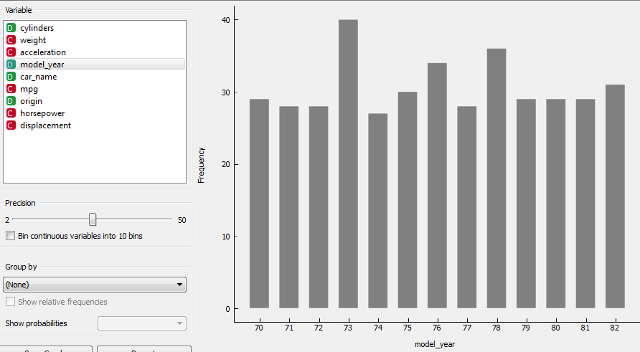

1. **Write a python script to display first 3 rows of auto-mpg.**

import Orange

data= Orange.data.Table("auto-mpg")

print(data.domain)

for d in data[:3]:

print (d)

p=[1]

for i in range(0,398):

p.append(data[i]['displacement'])

for i in range(0,398):

print(p)

print('max value is:')

print(max(p))

print('index of max value is:')

i=p.index(max(p))

print(i)

data= Orange.data.Table("auto-mpg")

print(data.domain)

for q in data[i-1]:

print (q)

1. **Write a python script to find the maximum displacement, its index and the corresponding row.**

import Orange

data= Orange.data.Table("auto-mpg")

for d in data[:5]:

print (d)

p=[398]

for i in range(0,398):

p.append(data[i]['displacement'])

for i in range(0,398):

print(p)

print('max value is:')

print(min(p))

print('index of max value is:')

i=p.index(min(p))

print(i)

**output**

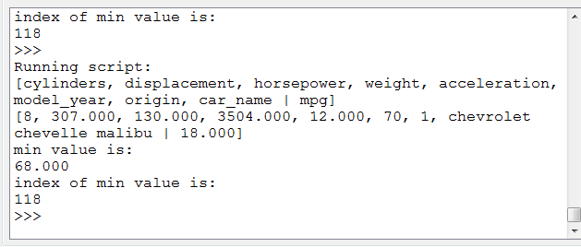

1. **Conclude about the number of cylinders. Add grouping of model_year in box plot to make conclusions.**

